13.Write a program to perform tree traversal
methods. Apply (Binary tree traversal)

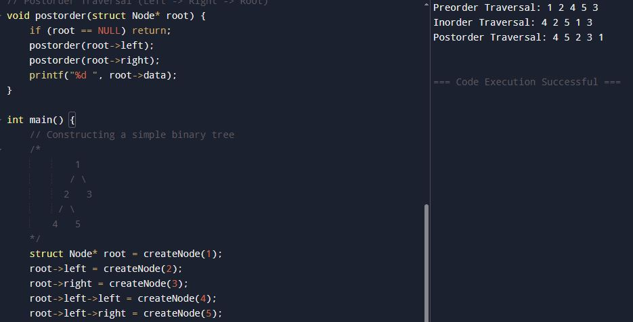
#include <stdio.h>
#include <stdlib.h>

// Define a node structure
struct Node {
int data;
struct Node* left;
struct Node* right;
};

// Function to create a new node
struct Node* createNode(int value) {
struct Node* newNode = (struct Node*)malloc(sizeof(struct Node));
newNode->data = value;
newNode->left = NULL;
newNode->right = NULL;
return newNode;
}

// Preorder Traversal (Root -> Left -> Right)
void preorder(struct Node* root) {
if (root == NULL) return;
printf("%d ", root->data);
preorder(root->left);
preorder(root->right);
}

// Inorder Traversal (Left -> Root -> Right)
void inorder(struct Node* root) {
if (root == NULL) return;
inorder(root->left);
printf("%d ", root->data);
inorder(root->right);
}

// Postorder Traversal (Left -> Right -> Root)
void postorder(struct Node* root) {
if (root == NULL) return;
postorder(root->left);
postorder(root->right);
printf("%d ", root->data);
}

int main() {
// Constructing a simple binary tree
/*
1
/ \
2 3
/ \
4 5
*/
struct Node* root = createNode(1);
root->left = createNode(2);
root->right = createNode(3);
root->left->left = createNode(4);
root->left->right = createNode(5);

printf("Preorder Traversal: ");
preorder(root);
printf("\n");

printf("Inorder Traversal: ");
inorder(root);
printf("\n");

printf("Postorder Traversal: ");
postorder(root);
printf("\n");

return 0;
}

14.Write a program to perform insertion and
deletion in the Binary Search Tree. Apply (Binary Search Tree
operations)
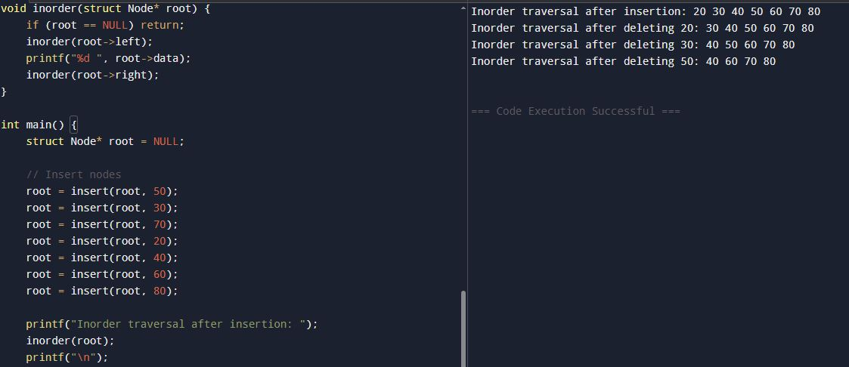
#include <stdio.h>
#include <stdlib.h>

// Define a node structure
struct Node {
int data;
struct Node* left;
struct Node* right;
};

// Function to create a new node
struct Node* createNode(int value) {
struct Node* newNode = (struct Node*)malloc(sizeof(struct Node));
newNode->data = value;
newNode->left = NULL;
newNode->right = NULL;
return newNode;
}

// Insert a node into BST
struct Node* insert(struct Node* root, int value) {
if (root == NULL) {
return createNode(value);
}
if (value < root->data) {
root->left = insert(root->left, value);
} else if (value > root->data) {
root->right = insert(root->right, value);
}
return root;
}

// Find the minimum value node (used in deletion)
struct Node* findMin(struct Node* root) {
while (root->left != NULL) {
root = root->left;
}
return root;
}

// Delete a node from BST
struct Node* deleteNode(struct Node* root, int value) {
if (root == NULL) return root;

if (value < root->data) {
root->left = deleteNode(root->left, value);
} else if (value > root->data) {
root->right = deleteNode(root->right, value);
} else {
// Node found
if (root->left == NULL) {
struct Node* temp = root->right;
free(root);
return temp;
} else if (root->right == NULL) {
struct Node* temp = root->left;
free(root);
return temp;
}
// Node with two children
struct Node* temp = findMin(root->right);
root->data = temp->data;
root->right = deleteNode(root->right, temp->data);
}
return root;
}

// Inorder Traversal (Left -> Root -> Right)
void inorder(struct Node* root) {
if (root == NULL) return;
inorder(root->left);
printf("%d ", root->data);
inorder(root->right);
}

int main() {
struct Node* root = NULL;

// Insert nodes
root = insert(root, 50);
root = insert(root, 30);
root = insert(root, 70);
root = insert(root, 20);
root = insert(root, 40);
root = insert(root, 60);
root = insert(root, 80);

printf("Inorder traversal after insertion: ");
inorder(root);
printf("\n");

// Delete nodes
root = deleteNode(root, 20);
printf("Inorder traversal after deleting 20: ");
inorder(root);
printf("\n");

root = deleteNode(root, 30);
printf("Inorder traversal after deleting 30: ");
inorder(root);
printf("\n");

root = deleteNode(root, 50);
printf("Inorder traversal after deleting 50: ");
inorder(root);
printf("\n");

return 0;
}

15.Write a program to represent an undirected
graph using the adjacency matrix to implement
the graph and perform the operations with
menu-driven options for the following tasks:
1. Create graph 2. Insert an edge 3. Print
Adjacency Matrix
4. List all vertices that are adjacent to a
specified vertex. 6. Exit program
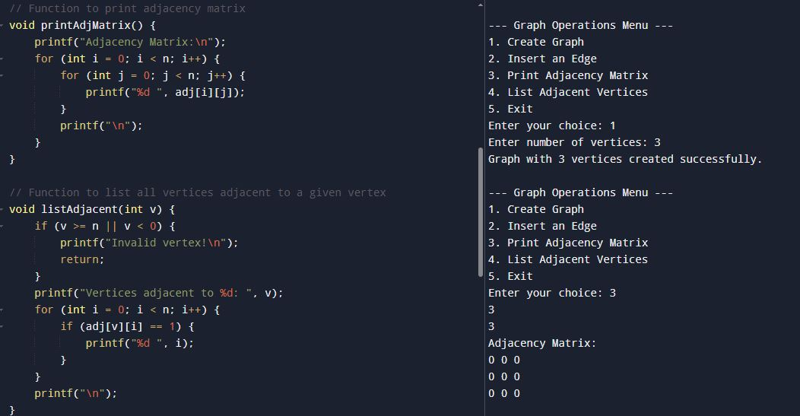
#include <stdio.h>
#include <stdlib.h>

#define MAX 20 // Maximum number of vertices

int adj[MAX][MAX]; // Adjacency matrix
int n; // Number of vertices

// Function to create graph
void createGraph(int vertices) {
n = vertices;
for (int i = 0; i < n; i++) {
for (int j = 0; j < n; j++) {
adj[i][j] = 0;
}
}
printf("Graph with %d vertices created successfully.\n", n);
}

// Function to insert an edge
void insertEdge(int u, int v) {
if (u >= n || v >= n || u < 0 || v < 0) {
printf("Invalid vertex!\n");
return;
}
adj[u][v] = 1;
adj[v][u] = 1; // Because graph is undirected
printf("Edge inserted between %d and %d.\n", u, v);
}

// Function to print adjacency matrix
void printAdjMatrix() {
printf("Adjacency Matrix:\n");
for (int i = 0; i < n; i++) {
for (int j = 0; j < n; j++) {
printf("%d ", adj[i][j]);
}
printf("\n");
}
}

// Function to list all vertices adjacent to a given vertex
void listAdjacent(int v) {
if (v >= n || v < 0) {
printf("Invalid vertex!\n");
return;
}
printf("Vertices adjacent to %d: ", v);
for (int i = 0; i < n; i++) {
if (adj[v][i] == 1) {
printf("%d ", i);
}
}
printf("\n");
}

int main() {
int choice, vertices, u, v;

while (1) {
printf("\n--- Graph Operations Menu ---\n");
printf("1. Create Graph\n");
printf("2. Insert an Edge\n");
printf("3. Print Adjacency Matrix\n");
printf("4. List Adjacent Vertices\n");
printf("5. Exit\n");
printf("Enter your choice: ");
scanf("%d", &choice);

switch (choice) {
case 1:
printf("Enter number of vertices: ");
scanf("%d", &vertices);
createGraph(vertices);
break;
case 2:
printf("Enter edge (u v): ");
scanf("%d %d", &u, &v);
insertEdge(u, v);
break;
case 3:
printAdjMatrix();
break;
case 4:
printf("Enter vertex: ");
scanf("%d", &v);
listAdjacent(v);
break;
case 5:
printf("Exiting program.\n");
exit(0);
default:
printf("Invalid choice! Try again.\n");
}
}
return 0;
}

16.Kalnirnay: Conversion from Gregorian
to Hindi calendar. Analyse (Linked list manipulation)
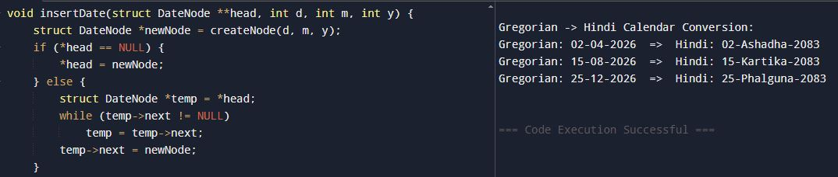
#include <stdio.h>
#include <stdlib.h>
#include <string.h>

// Hindi months mapping (simplified)
char *hindiMonths[] = {
"Chaitra", "Vaishakh", "Jyeshtha", "Ashadha",
"Shravana", "Bhadrapada", "Ashwin", "Kartika",
"Margashirsha", "Pausha", "Magha", "Phalguna"
};

// Linked list node
struct DateNode {
int gDay, gMonth, gYear; // Gregorian
int hDay, hMonth, hYear; // Hindi
char hMonthName[20];
struct DateNode *next;
};

// Function to create a new node
struct DateNode* createNode(int d, int m, int y) {
struct DateNode *newNode = (struct DateNode*)malloc(sizeof(struct DateNode));
newNode->gDay = d;
newNode->gMonth = m;
newNode->gYear = y;

// Conversion logic (simplified)
newNode->hYear = y + 57; // Vikram Samvat offset
newNode->hMonth = m; // Approximate mapping
newNode->hDay = d; // Same day for simplicity
strcpy(newNode->hMonthName, hindiMonths[m-1]);

newNode->next = NULL;
return newNode;
}
// Insert at end
void insertDate(struct DateNode **head, int d, int m, int y) {
struct DateNode *newNode = createNode(d, m, y);
if (*head == NULL) {
*head = newNode;
} else {
struct DateNode *temp = *head;
while (temp->next != NULL)
temp = temp->next;
temp->next = newNode;
}
}
// Display list
void displayDates(struct DateNode *head) {
printf("\nGregorian -> Hindi Calendar Conversion:\n");
while (head != NULL) {
printf("Gregorian: %02d-%02d-%d => Hindi: %02d-%s-%d\n",
head->gDay, head->gMonth, head->gYear,
head->hDay, head->hMonthName, head->hYear);
head = head->next;
}
}

int main() {
struct DateNode *calendar = NULL;

// Example conversions
insertDate(&calendar, 2, 4, 2026); // 2 April 2026
insertDate(&calendar, 15, 8, 2026); // 15 Aug 2026
insertDate(&calendar, 25, 12, 2026); // 25 Dec 2026
displayDates(calendar);
return 0;
}
17.Create a basic system that recommends irrigation time based on soil type and crop, using linked lists to store crop data. Analyse (Linked list manipulation)
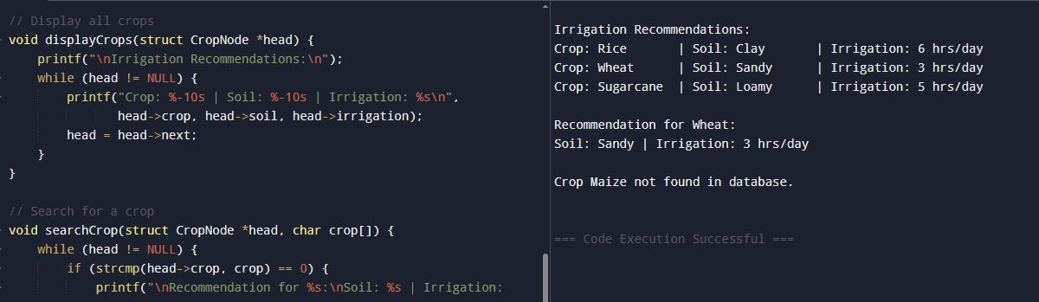
#include <stdio.h>
#include <stdlib.h>
#include <string.h>

// Linked list node
struct CropNode {
char crop[30];
char soil[30];
char irrigation[50];
struct CropNode *next;
};

// Function to create a new node
struct CropNode* createNode(char crop[], char soil[], char irrigation[]) {
struct CropNode *newNode = (struct CropNode*)malloc(sizeof(struct CropNode));
strcpy(newNode->crop, crop);
strcpy(newNode->soil, soil);
strcpy(newNode->irrigation, irrigation);
newNode->next = NULL;
return newNode;
}

// Insert at end
void insertCrop(struct CropNode **head, char crop[], char soil[], char irrigation[]) {
struct CropNode *newNode = createNode(crop, soil, irrigation);
if (*head == NULL) {
*head = newNode;
} else {
struct CropNode *temp = *head;
while (temp->next != NULL)
temp = temp->next;
temp->next = newNode;
}
}

// Display all crops
void displayCrops(struct CropNode *head) {
printf("\nIrrigation Recommendations:\n");
while (head != NULL) {
printf("Crop: %-10s | Soil: %-10s | Irrigation: %s\n",
head->crop, head->soil, head->irrigation);
head = head->next;
}
}

// Search for a crop
void searchCrop(struct CropNode *head, char crop[]) {
while (head != NULL) {
if (strcmp(head->crop, crop) == 0) {
printf("\nRecommendation for %s:\nSoil: %s | Irrigation: %s\n",
head->crop, head->soil, head->irrigation);
return;
}
head = head->next;
}
printf("\nCrop %s not found in database.\n", crop);
}

int main() {
struct CropNode *list = NULL;

// Insert sample data
insertCrop(&list, "Rice", "Clay", "6 hrs/day");
insertCrop(&list, "Wheat", "Sandy", "3 hrs/day");
insertCrop(&list, "Sugarcane", "Loamy", "5 hrs/day");

// Display all
displayCrops(list);

// Search example
searchCrop(list, "Wheat");
searchCrop(list, "Maize");

return 0;
}

18.Design and implement a queue-based appointment management system for a clinic that handles patients in the order of their arrival. The system should maintain a First-Come, FirstServed (FCFS) queue for patients and provide options to add new patients, view the next patient to be treated, serve (remove) a patient once treated,
and display the list of all waiting patients.
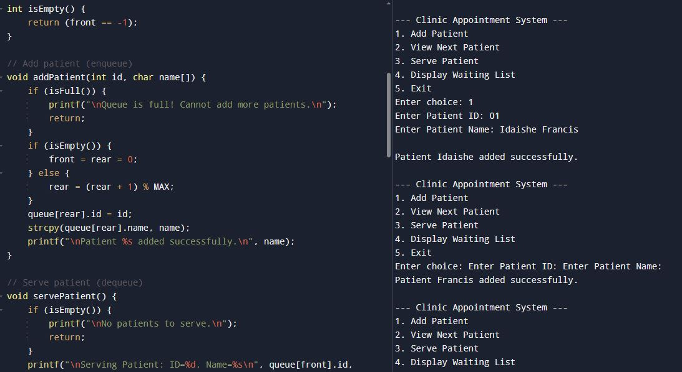
#include <stdio.h>
#include <stdlib.h>
#include <string.h>

#define MAX 5 // Maximum patients in queue

// Patient structure
struct Patient {
int id;
char name[30];
};

// Circular Queue
struct Patient queue[MAX];
int front = -1, rear = -1;

// Check if queue is full
int isFull() {
return (front == (rear + 1) % MAX);
}

// Check if queue is empty
int isEmpty() {
return (front == -1);
}

// Add patient (enqueue)
void addPatient(int id, char name[]) {
if (isFull()) {
printf("\nQueue is full! Cannot add more patients.\n");
return;
}
if (isEmpty()) {
front = rear = 0;
} else {
rear = (rear + 1) % MAX;
}
queue[rear].id = id;
strcpy(queue[rear].name, name);
printf("\nPatient %s added successfully.\n", name);
}

// Serve patient (dequeue)
void servePatient() {
if (isEmpty()) {
printf("\nNo patients to serve.\n");
return;
}
printf("\nServing Patient: ID=%d, Name=%s\n", queue[front].id, queue[front].name);
if (front == rear) {
front = rear = -1; // Queue becomes empty
} else {
front = (front + 1) % MAX;
}
}

// View next patient
void viewNextPatient() {
if (isEmpty()) {
printf("\nNo patients waiting.\n");
return;
}
printf("\nNext Patient: ID=%d, Name=%s\n", queue[front].id, queue[front].name);
}

// Display all patients
void displayQueue() {
if (isEmpty()) {
printf("\nNo patients in queue.\n");
return;
}
printf("\nPatients Waiting:\n");
int i = front;
while (1) {
printf("ID=%d, Name=%s\n", queue[i].id, queue[i].name);
if (i == rear) break;
i = (i + 1) % MAX;
}
}

int main() {
int choice, id;
char name[30];

while (1) {
printf("\n--- Clinic Appointment System ---\n");
printf("1. Add Patient\n");
printf("2. View Next Patient\n");
printf("3. Serve Patient\n");
printf("4. Display Waiting List\n");
printf("5. Exit\n");
printf("Enter choice: ");
scanf("%d", &choice);

switch (choice) {
case 1:
printf("Enter Patient ID: ");
scanf("%d", &id);
printf("Enter Patient Name: ");
scanf("%s", name);
addPatient(id, name);
break;
case 2:
viewNextPatient();
break;
case 3:
servePatient();
break;
case 4:
displayQueue();
break;
case 5:
exit(0);
default:
printf("\nInvalid choice!\n");
}
}
return 0;
}

